**A Very Basic Guide to Remapping Controllers for Ostim and Wheeler Functionality**

**Part 3 Mapping Ostim and Wheeler in Steam Controller App**

1. Fire up skyrim through steam launcher.
2. Load a save. Make sure you have the controller turned on in settings.
3. Back at the main game screen press shift and tab together which should open the steam overlay. See below.

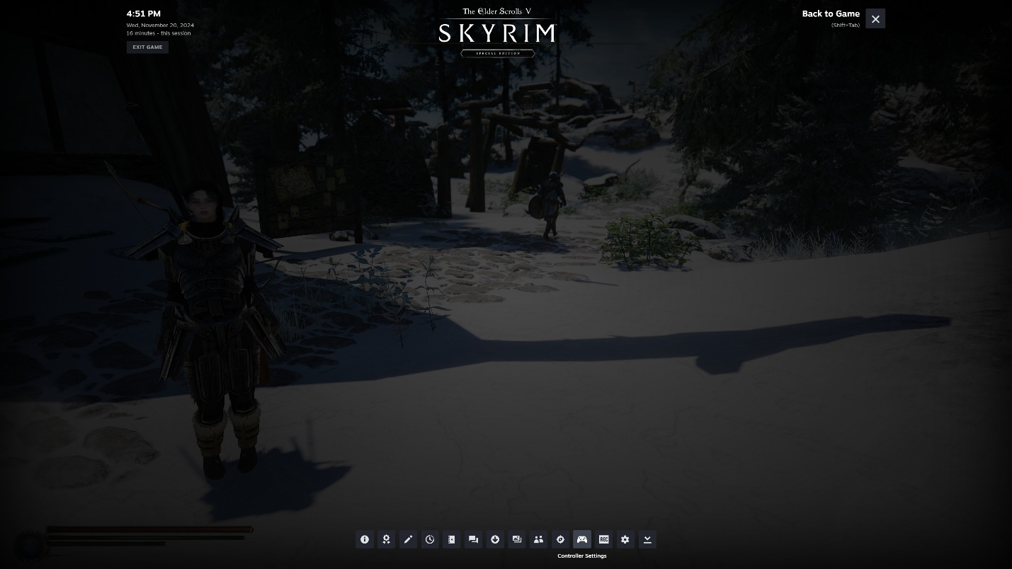

1. Click on the controller settings button at the bottom.
2. It should bring up the following window. Click edit layout.

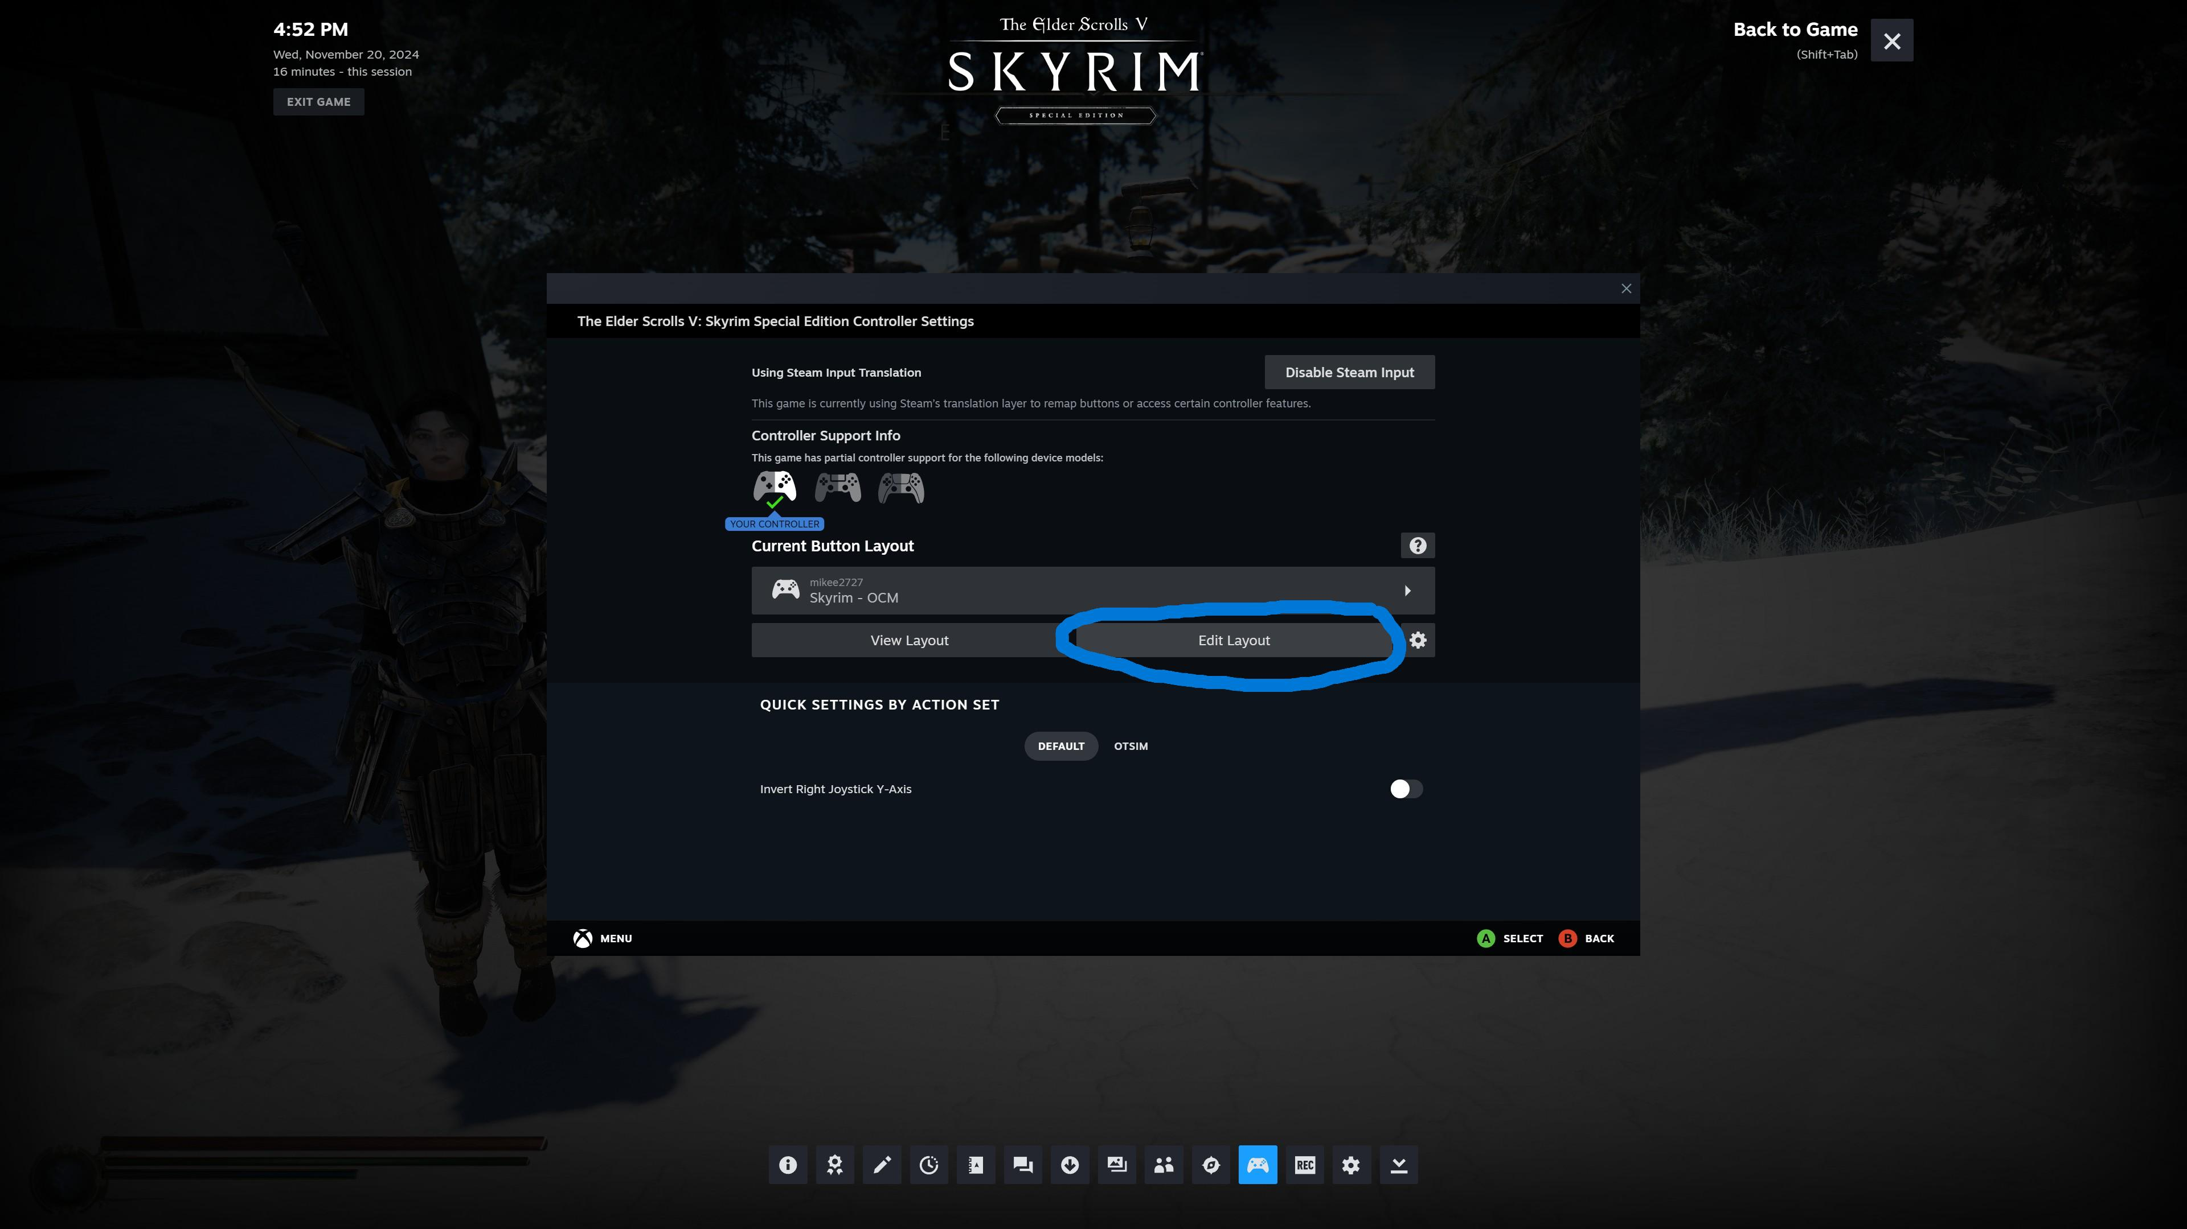

1. Now it should open the following window. This should be your default action set which is the regular operation of your controller. Click through stuff and see how things are set here but don’t change anything here, this set should always stay default other then the two directional pad keys we are going to change.

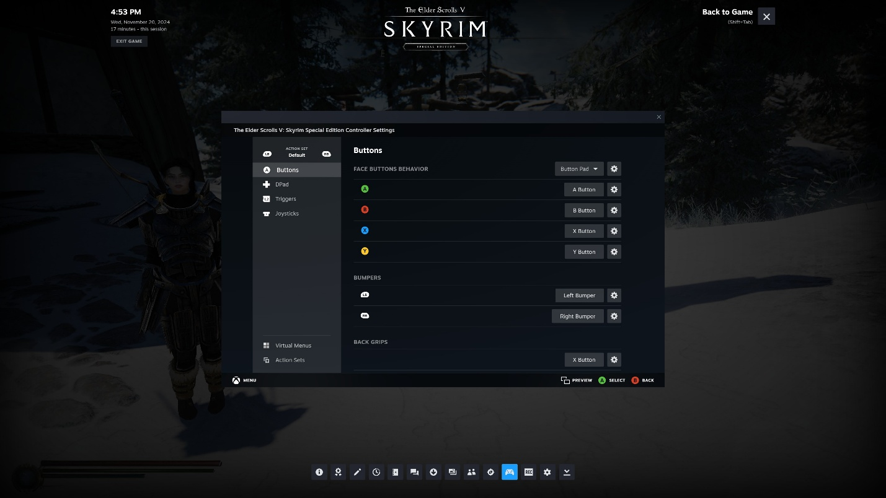

1. Once you have familiarized yourself with it, click on action sets in the bottom left corner. Then click add action set. We are going to create two so do these same steps to add the Wheeler one after. Name the first one OStim. And hit confirm. Then add another and name it Wheeler and hit confirm.

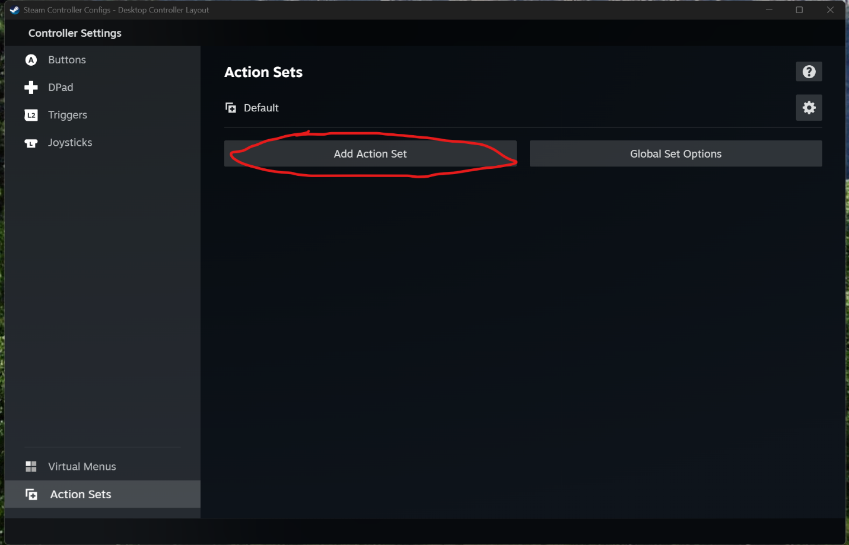

1. Now we have the three sets we will need to map the buttons onto. The way an action set works is when you switch to it, the buttons on the controller all change to what they are set to be in that action set. So on the default action set you will only want to add buttons to change the action sets and activate whatever mode you are trying to work. In the top left corner it should say which action set you are in currently, it should say default. Click on DPad. Then click on “left arrow key”. We are going to add two commands to this one key. First will be your key that activates Ostim, default is “up arrow” on the keyboard and mine was “right shift” on the keyboard but put whatever you have in. You will see the menu below when you click the “left arrow key”. Notice the top line, you can map any command from anyone of those categories to a button. So pick keyboard and then pick the key that opens your Ostim, if you left it “up arrow” then it is under numberpad instead of keyboard.

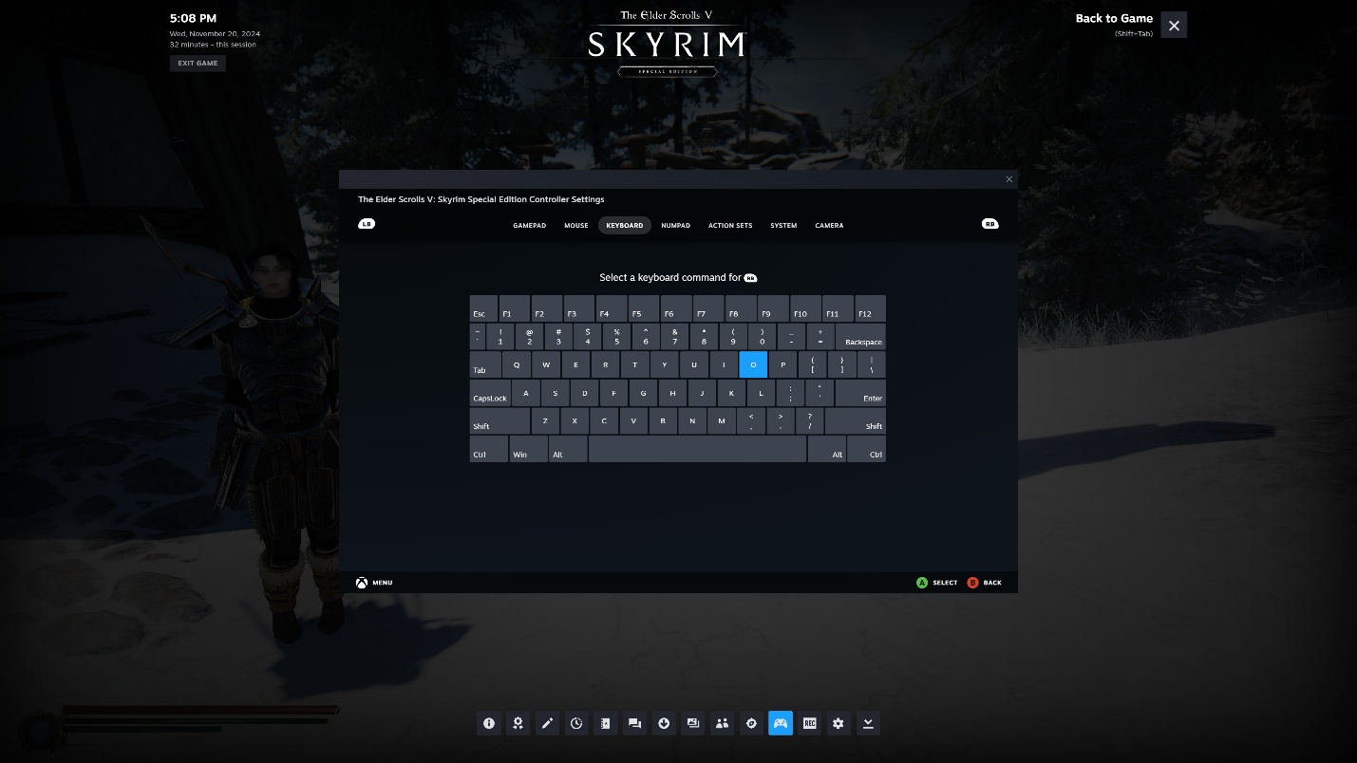

1. Next click the gear icon next to the key you just added and then choose add extra command.
2. This time choose action set up top, then change action set, then select Ostim where it says set and hit confirm. Your keys should look something like this now.

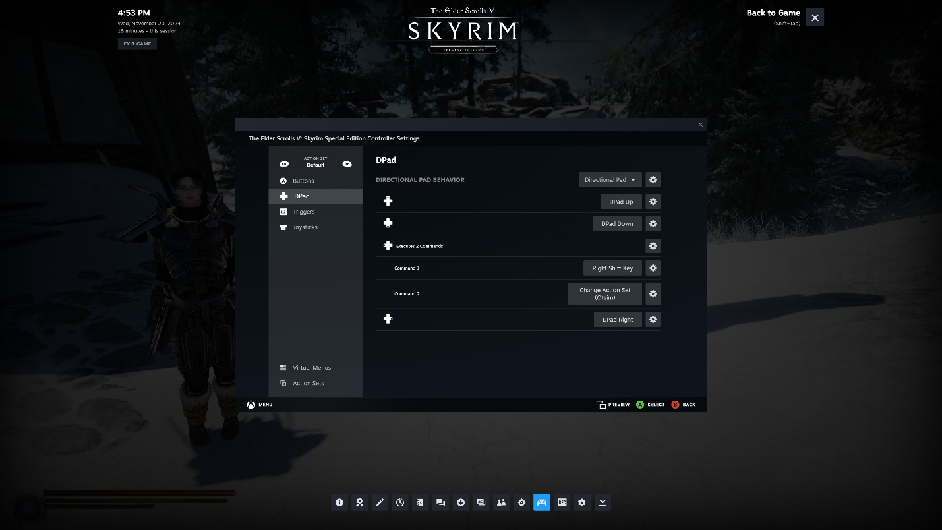

1. Now follow those same steps to add Wheeler to the Dpad Right key, obviously you want to add your wheeler activation key (default is Z) and then the change to Wheeler action set command. When you are done it should look like below.

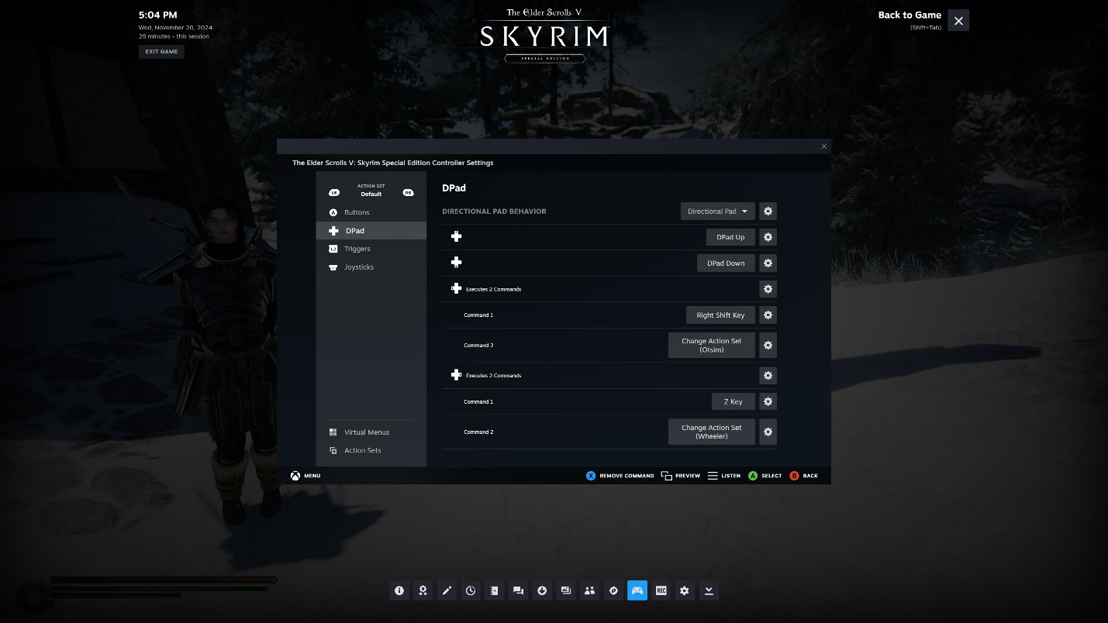

1. Now we need to program the keys in each action set. At the top of the left column you should see default between left and right bumper keys. Click the right bumper key and it should switch the action set to Ostim.

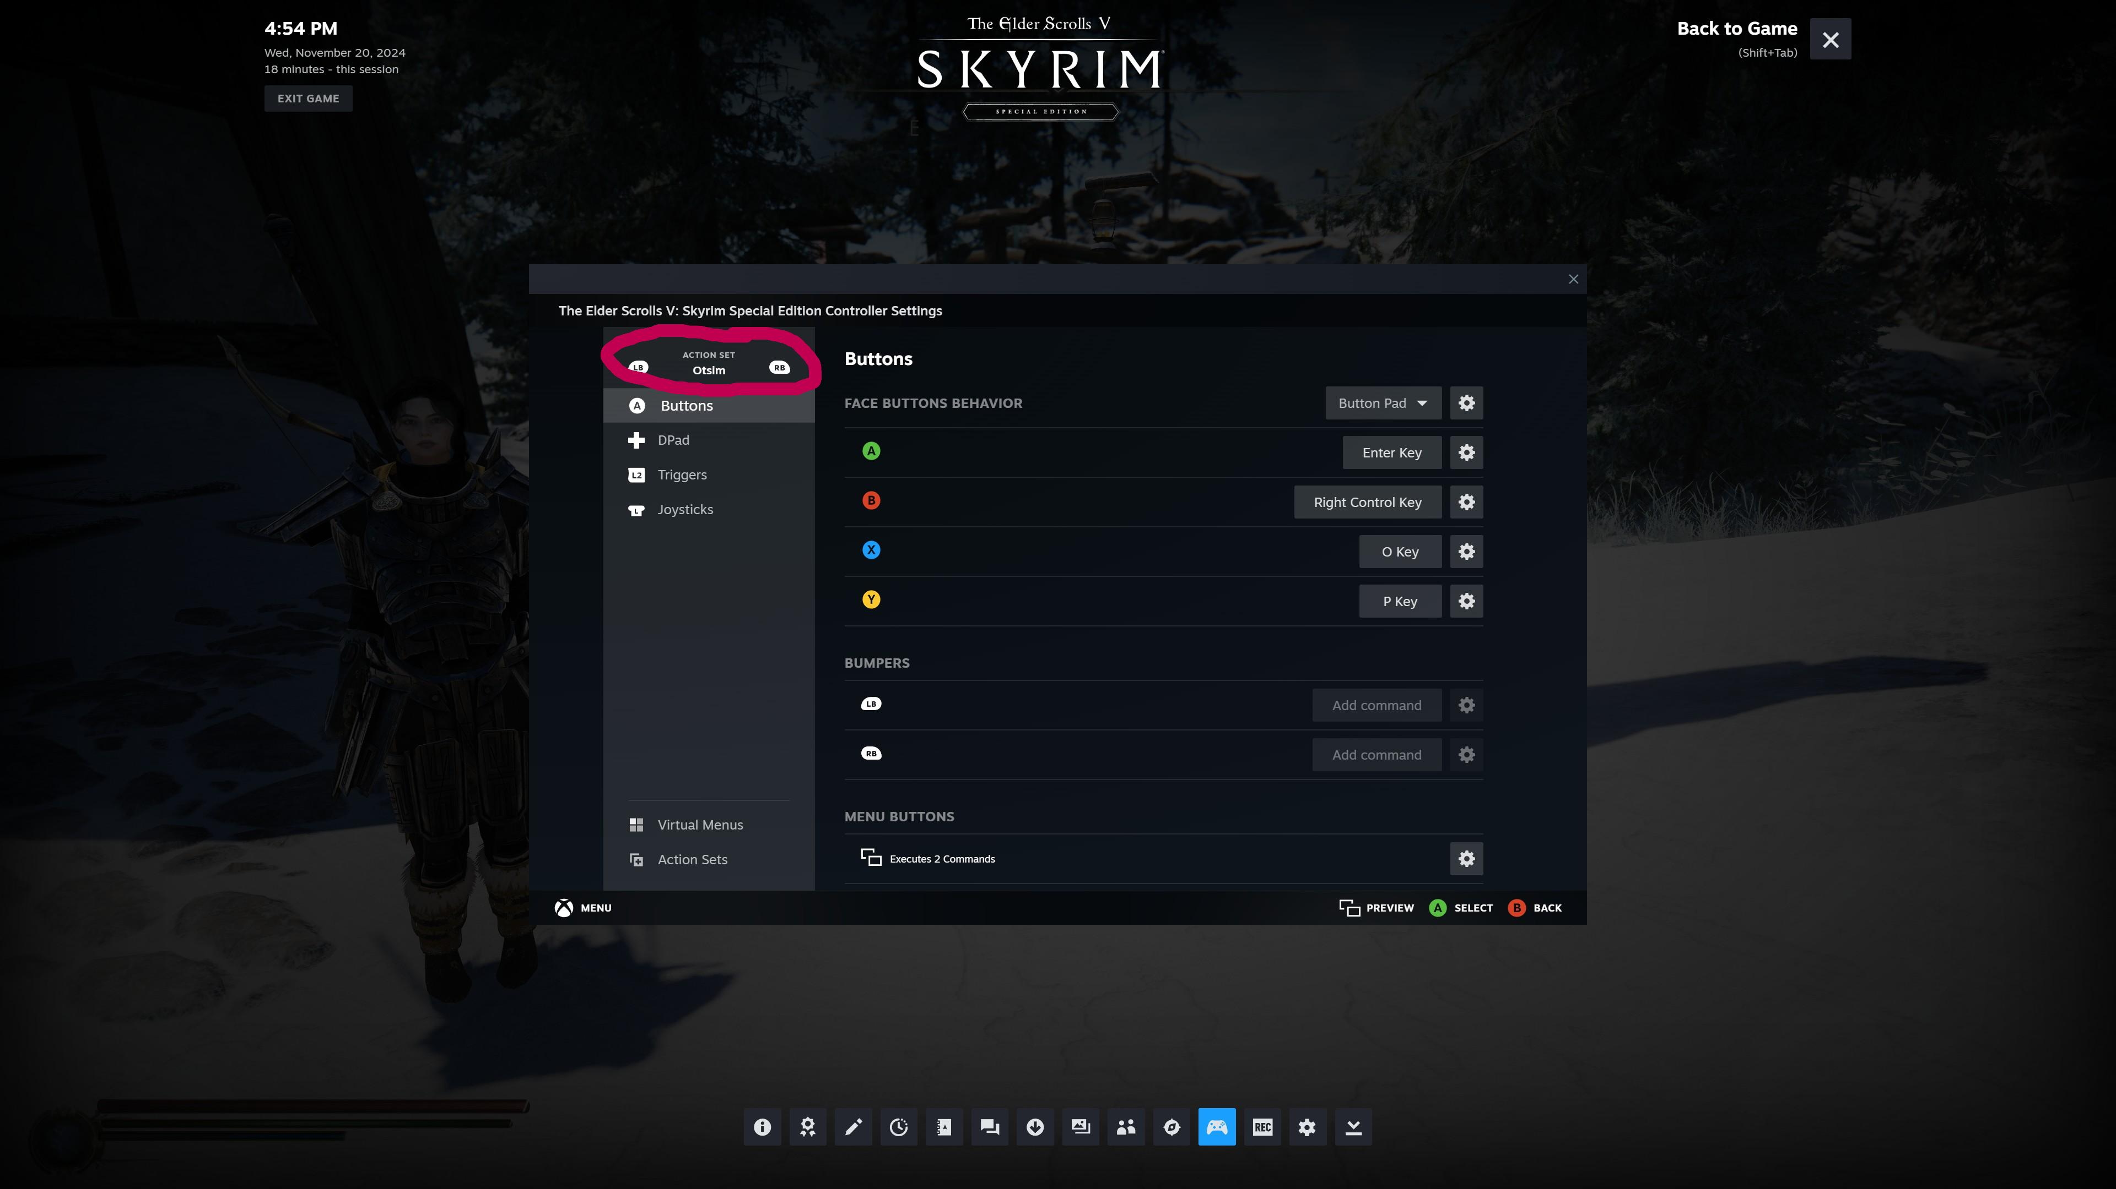

1. Your keys in this section will all be blank. You will need to map each key with whatever function you want. When you are done you will need to do each Wheeler key. It is important to remember to also give your joysticks their default functionality or you will not be able to move the camera in Ostim mode. It is also very important to give yourself a way back to the default action set in both Ostim and Wheeler sets. I used the Select keys and gave them the dual function commands of end Ostim/Wheeler and a secondary action of change to default action set. Below are my three action set maps.

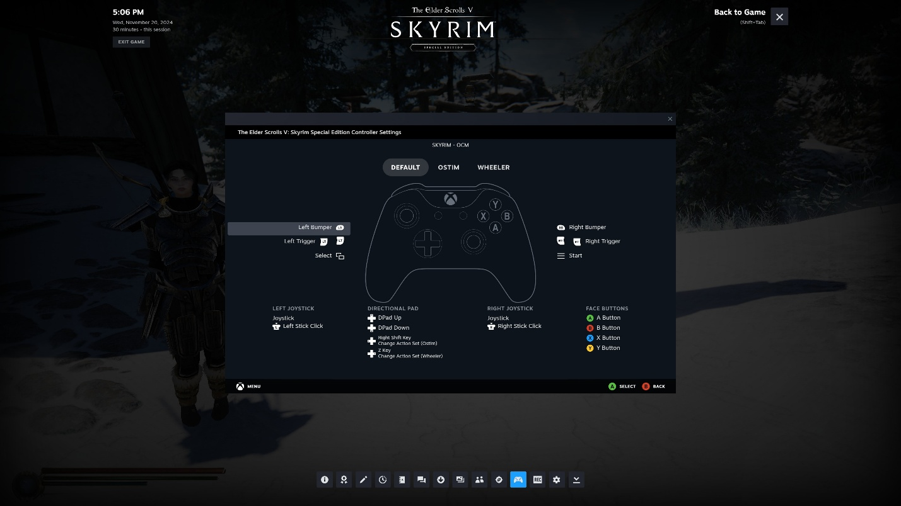

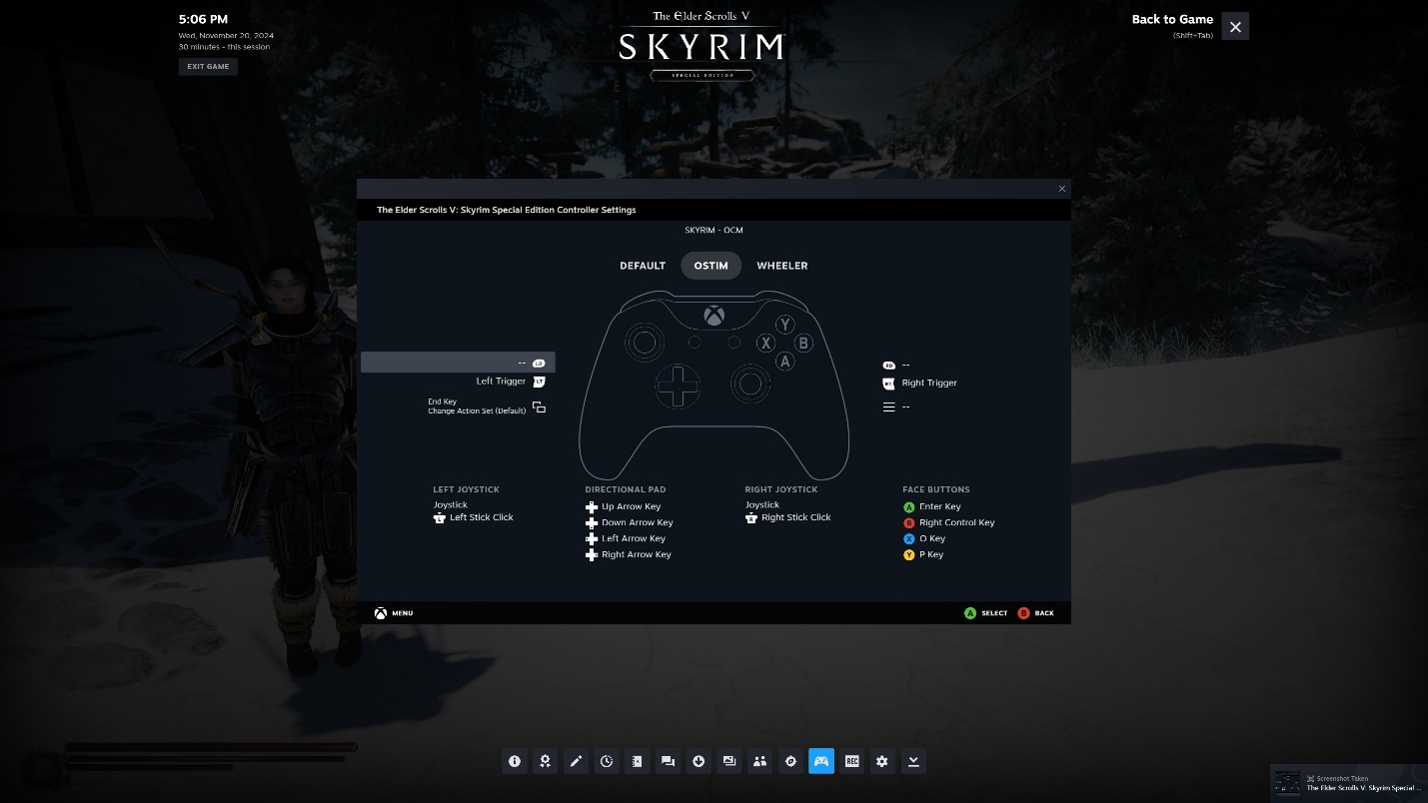

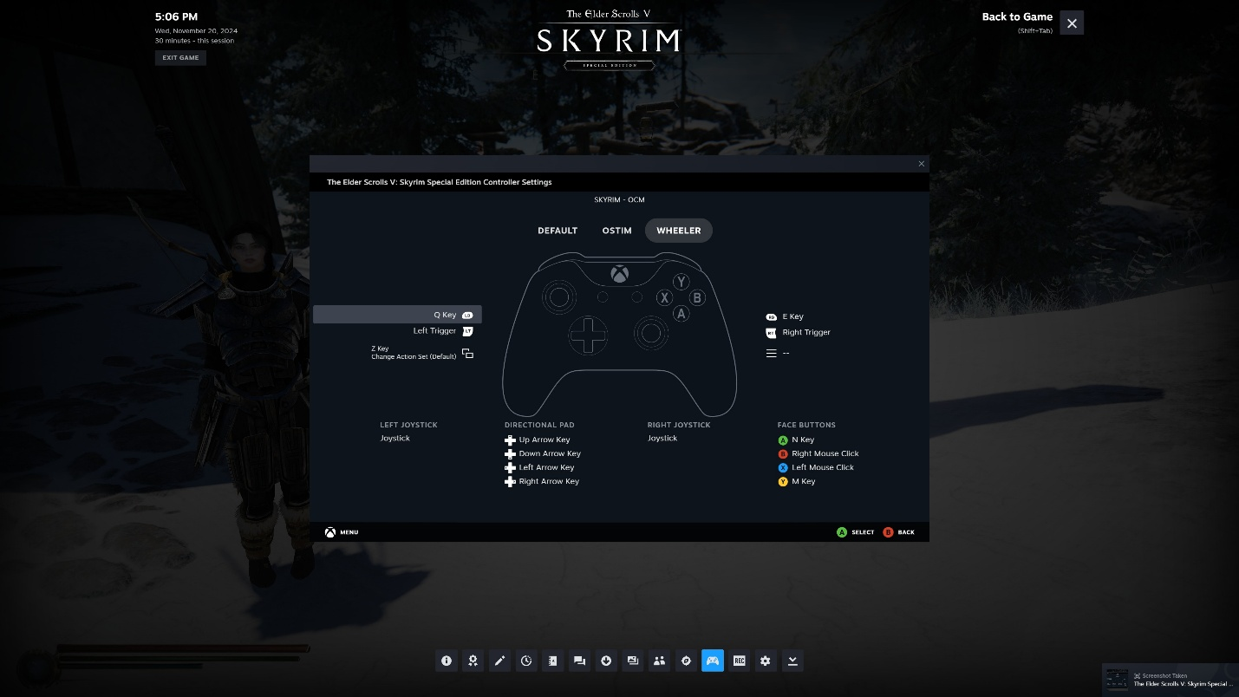

1. Follow mine or set your own but they should be similar. You are just mapping whatever keyboard/Mouse keys that make sense to you. In game if you want to enter Ostim you walk up to someone and press the left arrow on the dpad and it will change your gamepad to use the correct commands and put you in Ostim mode. When finished press the select key and it will send you back to the normal game and set your gamepad back.
2. When you are all done setting your buttons hit back until you get to the first screen as seen below. Click the gear icon next to edit layout and export your layout by hitting save new layout. Then hit back again and Shift tab to close the steam overlay. Now test your controller. Go back into the steam overlay for any tweaking you want to do.

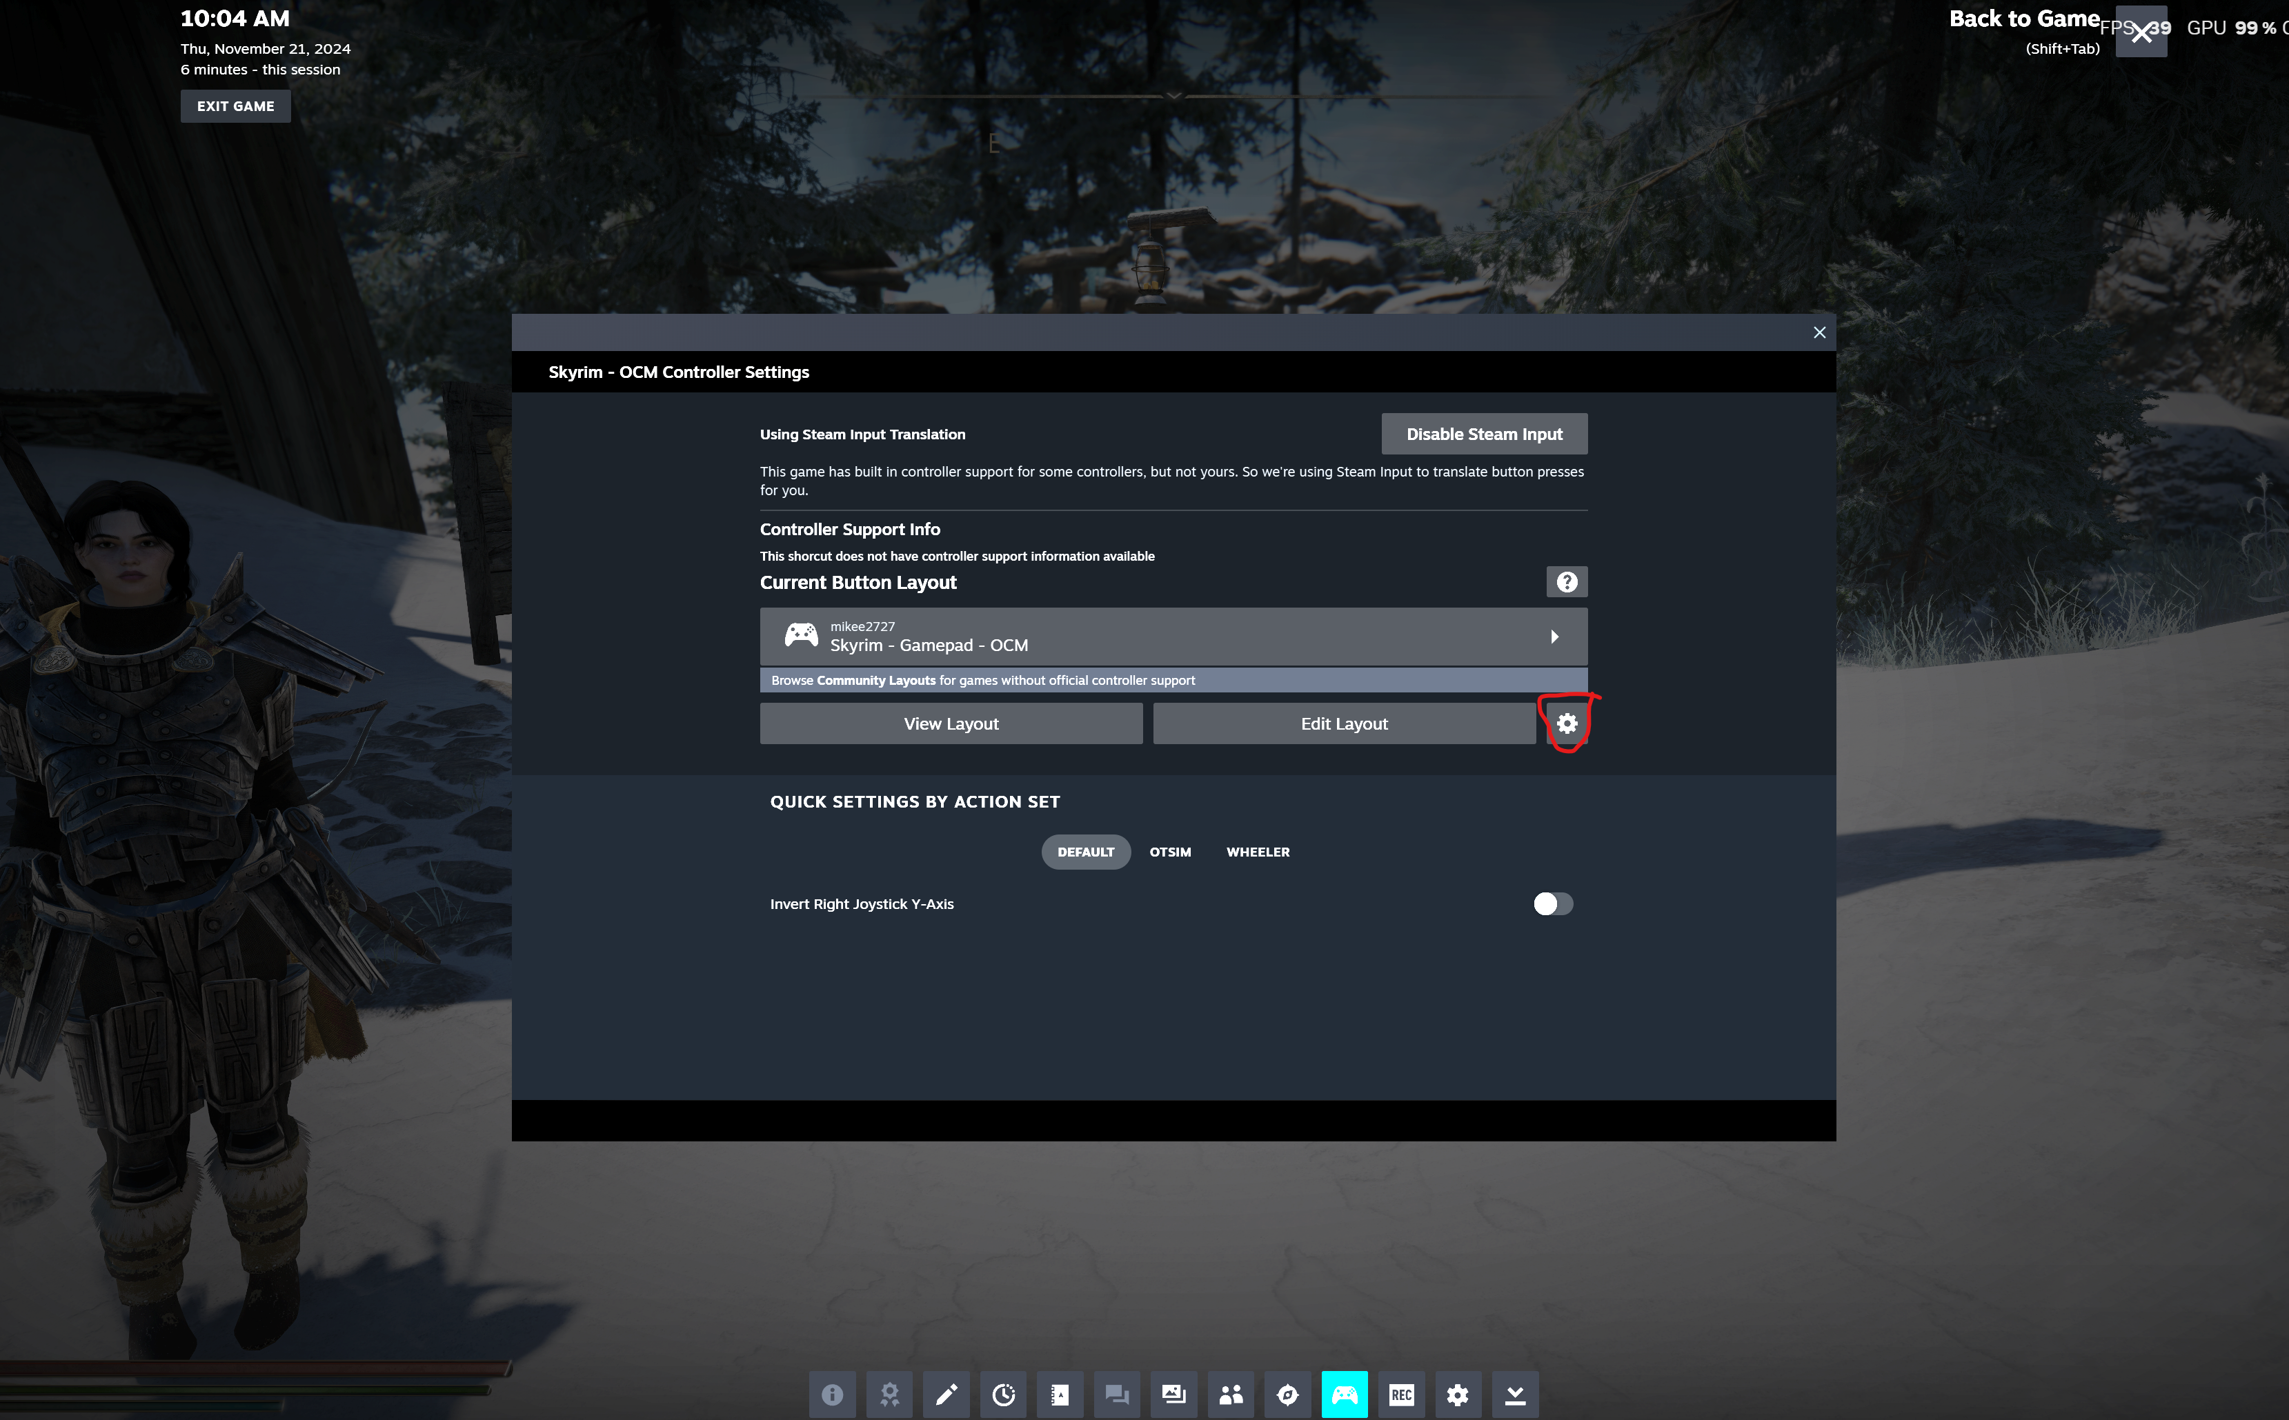

I am not going to get into how to setup wheeler in game. Go to the nexus page for the mod to learn that, all I am providing is a way for it work with a gamepad a little bit better. There may even be a more intuitive way to do it with the layer function, but I haven’t messed with it yet. This is just a very preliminary go at all this. I am happy with the way Ostim works but I feel the wheeler functions can probably be setup better and anything anyone comes up with that is better let me know.